Task

1. Find and print area of square with 10cm breadth and width (pseudocode & flowchart)

**Pseudocode**

* Start
* Initialize area, wide, long
* Input wide = 10, long = 10
* Process area = wide * long
* Print area
* Stop

**Flowchart**

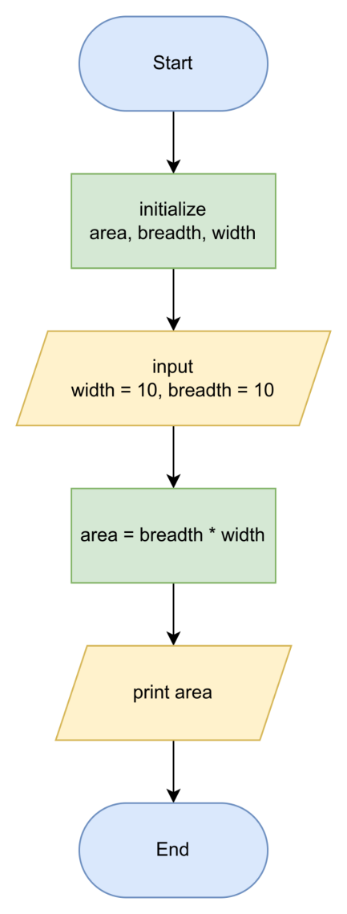

1. Find and print perimeter of square with 10cm side (pseudocode & flowchart)

**pseudocode**

* Start
* Initialize perimeter, side
* Input side = 10
* Process perimeter = 4 * side
* Print perimeter
* Stop

**flowchart**

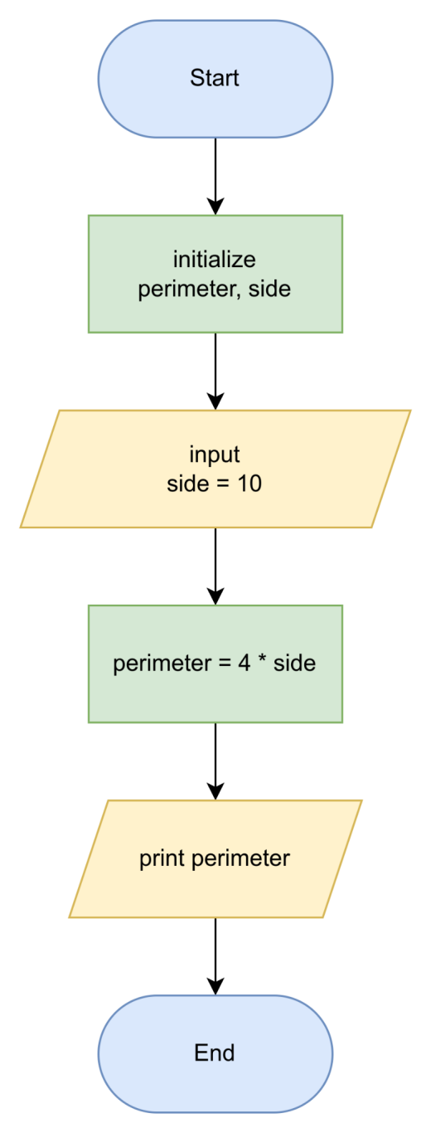

1. Create flowchart and pseudocode of a program to find the smallest number with two given different numbers

**pseudocode**

* Start
* Initialize num1, num2
* Input num1, num2
* if num1 > num2

then print num2

else print num1

* Stop

**flowchart**

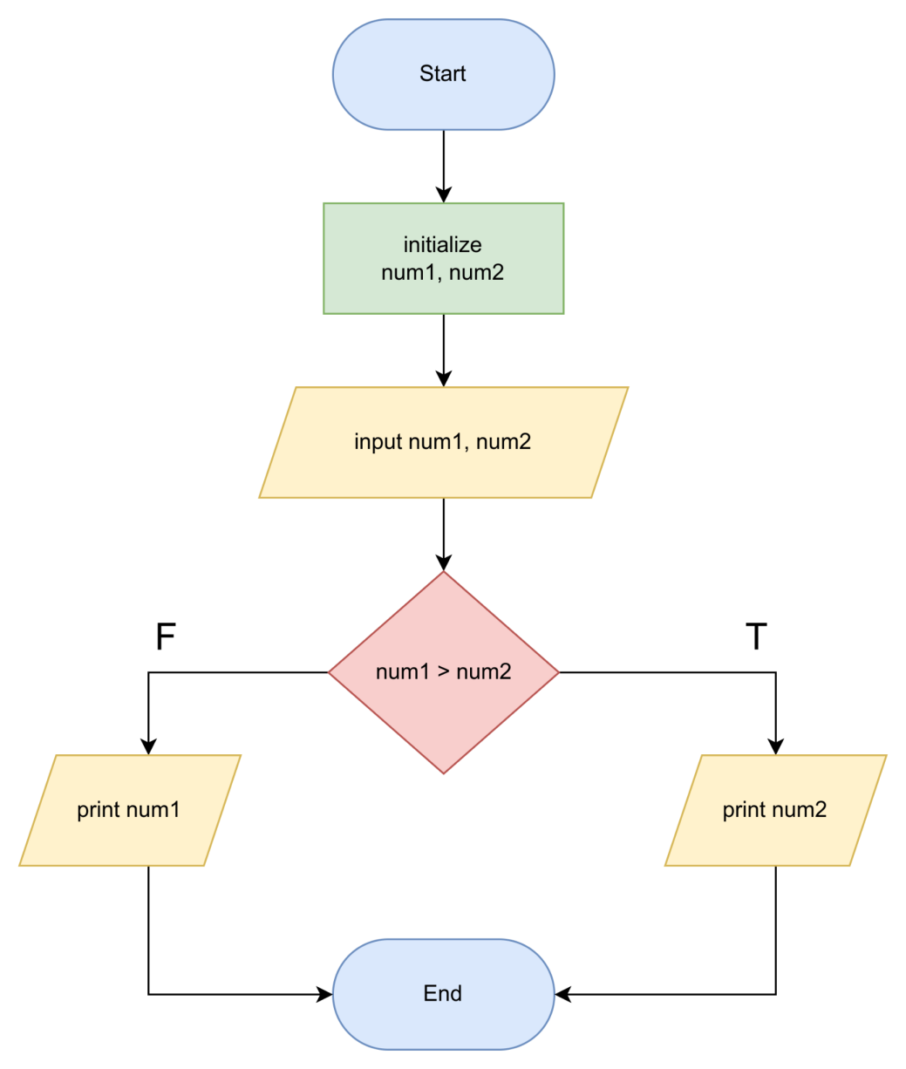

1. Answer

**pseudocode**

* Start
* Initialize num1, num2
* Input num1, num2
* if num1 == num2 then print “SAMA”

else if num1 > num2 then print(num1 + num2)

else then print(num2 - num1)

* Stop

**flowchart**

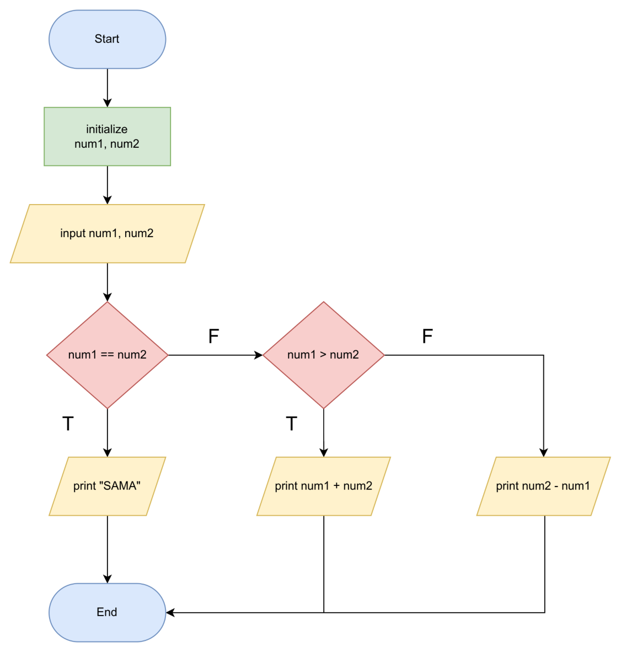

1. Answer

**Pseudocode A**

* Start
* Input N
* if N > 50 then N = N - 25
* N = N + 10
* Print N
* Stop

**Pseudocode B**

* Start
* Input N
* if N > 50 then N = N - 25

else N = N + 10

* Print N
* Stop

**What’s the output if N is :**

* **30**

Output of flowchart 5-1 is 40

Output of flowchart 5-2 is 40

* **50**

Output of flowchart 5-1 is 60

Output of flowchart 5-2 is 60

* **65**

Output of flowchart 5-1 is 50

Output of flowchart 5-2 is 40

1. Answer

Flowchart 6-1

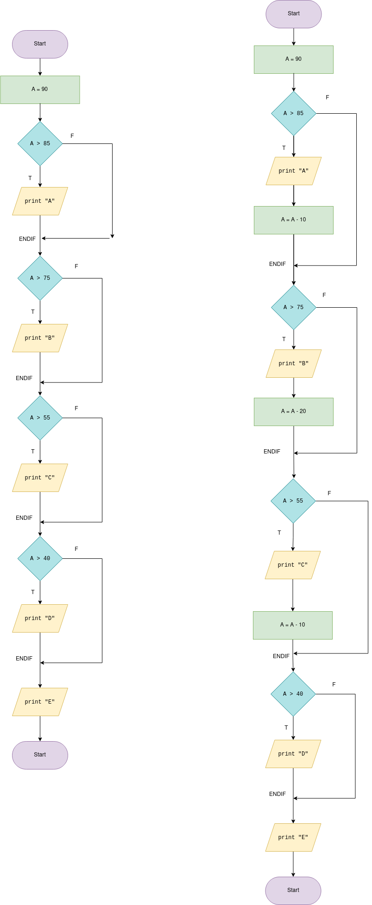

Flowchart 6-2



Output from each pseudo code

Flowchart 6 - 1

>> A

>> B

>> C

>> D

>> E

Flowchart 6 - 2

>> A

>> B

>> C

>> D

>> E

>> 50